**Azad Kashmir:**

Banjosa Lake

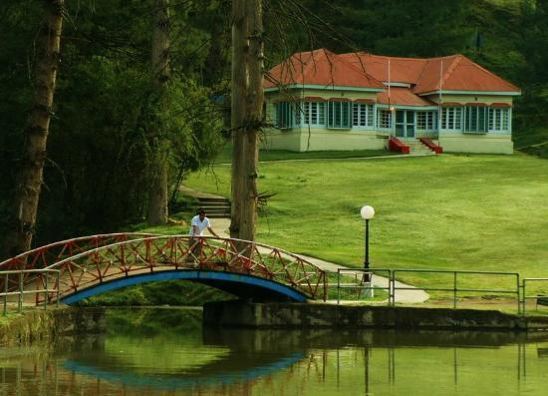

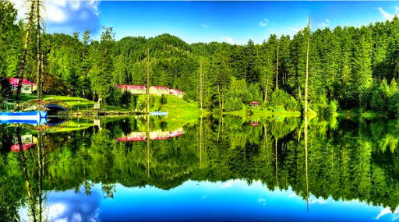

**Banjosa Lake** is an artificial lake and a tourist resort 18 kilometers (11mi) from the city of Rawalakot in Poonch District of Azad Kashmir, Pakistan. It is located at an altitude of 1,981 meters (6,499ft).